**Microprocessor and Computer Architecture**

**UE21CS251B**

**4th Semester, Academic Year 2021-22**

Date:

|  |  |  |
| --- | --- | --- |
| Name: Atharva Menkudle | SRN: PES2UG21CS104 | Section  B |

**Include in your submission**

ARM Assembly Code(1)

Output Screen Shot (1)

Week#____2______ Program Number: ____1___

Title of the Program

1. **Write an ALP to add two 32 bit numbers loaded from memory and store the result in memory**

ARM Assembly Code

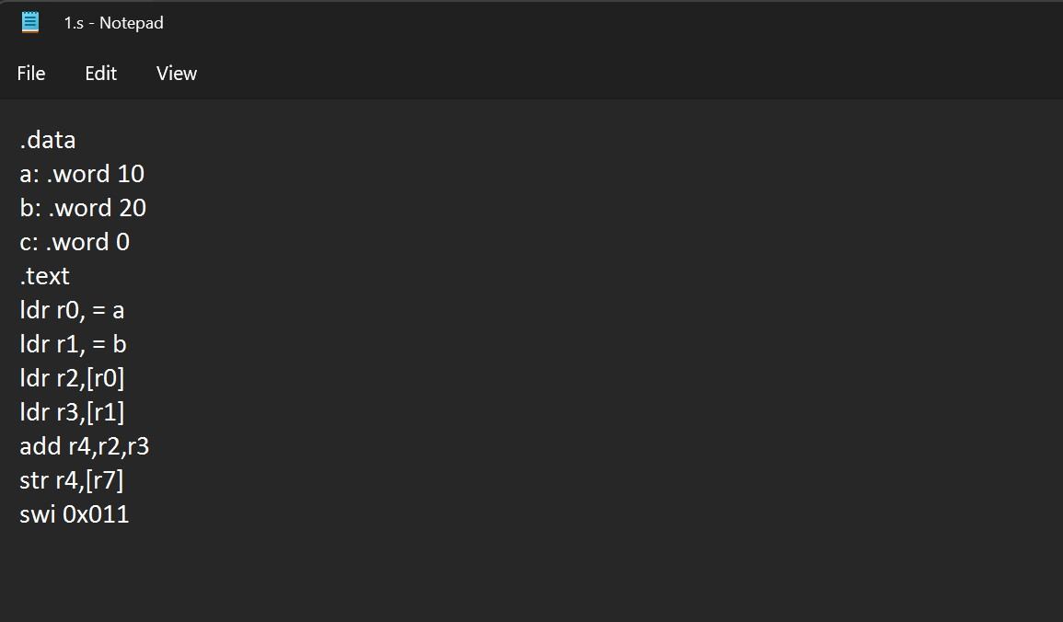

Output Screen Shot

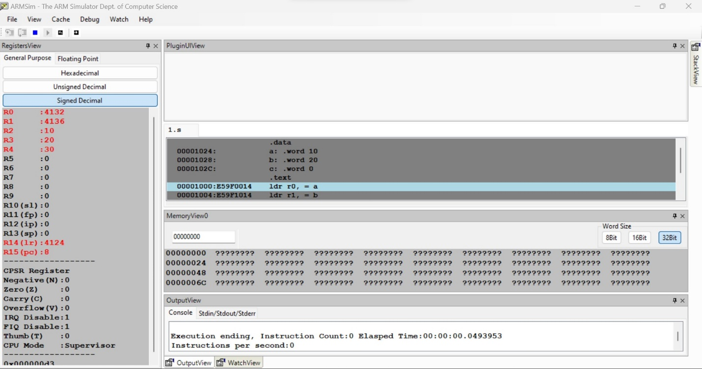

Week#____2_______ Program Number: ____2___

Title of the Program

Write an ALP to add two 16 bit numbers loaded from memory and store the result in memory.

Week#____2_______ Program Number: ____3___

Title of the Program

**Write an ALP to copy n numbers from Location A to Location B.**

Week#____2_______ Program Number: ____4___

Title of the Program

**Write an ALP to find the factorial of a number stored in R0. Store the value in R1 (without using LDR and STR instructions)**

Week#____2_______ Program Number: ____5__

Title of the Program

**Write an ALP to find GCD of two numbers (without using LDR and STR instructions).Both numbers are in registers**

ARM Assembly Code

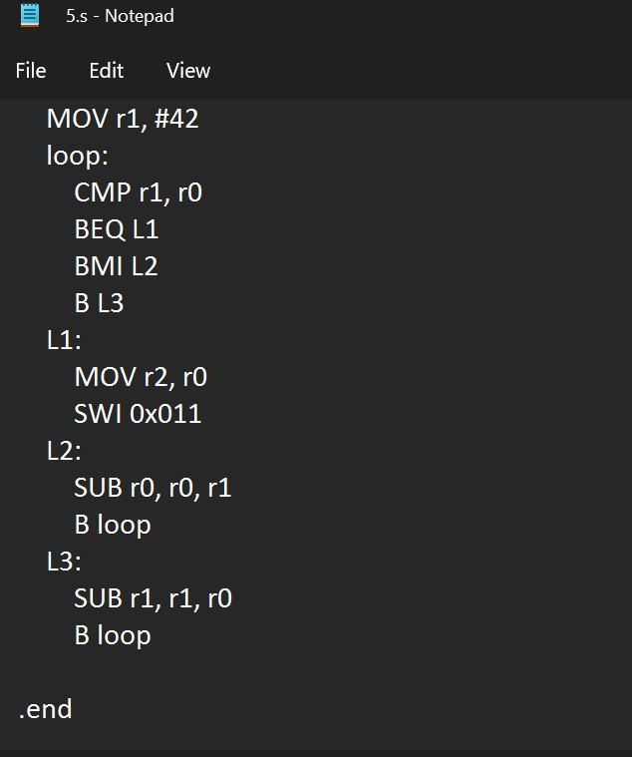

Output Screen Shot

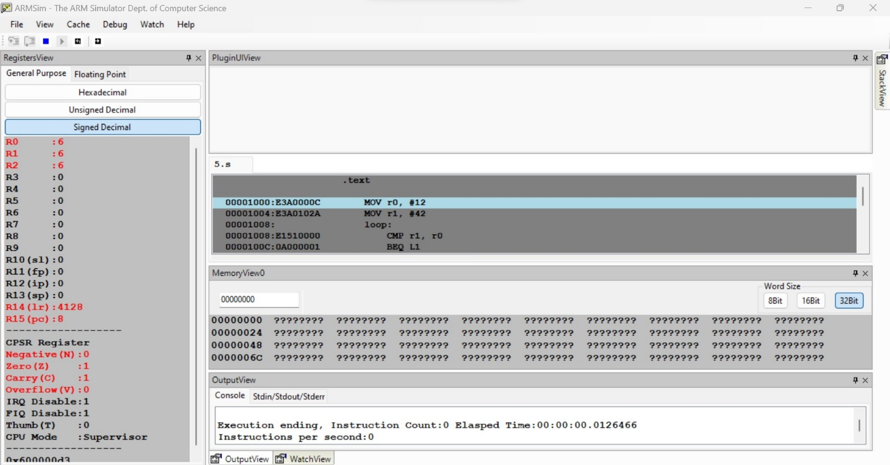

Week#____2_______ Program Number: ____6___

Title of the Program

**Write an ALP to find the GCD of given numbers (both numbers in memory). Store result in memory.**

Week#____2_______ Program Number: ____7___

Title of the Program

**Write an ALP to add an array of ten 32 bit numbers from memory.**

Week#____2_______ Program Number: ____8___

Title of the Program

**Add array of ten 16 bit numbers taking data from memory location stored as byte data (use .byte to store the data instead of .word)**

**Disclaimer:**

* The programs and output submitted is duly written, verified and executed by me.
* I have not copied from any of my peers nor from the external resource such as internet.
* If found plagiarized, I will abide with the disciplinary action of the University.

Signature: Atharva Menkudle

Name: Atharva Menkudle

SRN: PES2UG21CS104

Section: B

Date: 19/1/23